Team Members

Rohit Raj
rohit314.raj@gmail.com
9901162178
Computer Science and Engineering
BVBCET, Hubli

Suraj R. Prabhu
surajrp77@gmail.com
9481871177
Computer Science and Engineering
BVBCET, Hubli

Nirusha Shetty
nirusha157@gmail.com
9916378131
Computer Science and Engineering
BVBCET, Hubli

Piyush Kumar Singh
piyushksingh2012@gmail.com
9036295013
Computer Science and Engineering
BVBCET, Hubli

Content Based Image Retrieval using Hexagonal Resampling and Detection of Ailments in MRI scans of Brain

Rohit Raj
Department of Computer Science and Engineering
B.V.B. College of Engineering & Technology
Hubli, India
rohit314.raj@gmail.com

Suraj R. Prabhu
Department of Computer Science and Engineering
B.V.B. College of Engineering & Technology
Hubli, India
surajrp77@gmail.com

Nirusha Shetty
Department of Computer Science and Engineering
B.V.B. College of Engineering & Technology
Hubli, India
nirusha157@gmail.com

Piyush Singh
Department of Computer Science and Engineering
B.V.B. College of Engineering & Technology
Hubli, India
piyushksingh2012@gmail.com

Abstract—Image processing is an expanding field with its applications spreading across several domains. There is extensive use of digital images for medical purposes which involves critical decisions to be made based on the elucidation of medical images such as MRI scan, CT scan, X-ray etc., and calls for substantial research. This paper is based on the project aimed at processing of MRI scans of brain. The proposed system performs content based retrieval of cases similar to the MRI scan loaded as query using Gabor wavelet based edge detection on hexagonal resampled grid, and proposes an algorithm for identification of ailment, if present. The work is restricted to identification of three brain pathologies viz. tumour, bleed and infarction. The project intends to assist doctors in identifying the abnormalities.

Keywords: CBIR, MRI, Gabor filter, GLCM, moment invariants, Euclidean distance, precision and recall.

- Introduction
Content based image retrieval, CBIR, involves looking for similar images based on the content of the images rather than the metadata as in text based image retrieval. Features such as colour, shape and texture are extracted from the image and these serve as basis for further processing. Normal images are found to be in rectangular lattice, transforming them to hexagonal grid using re-sampling delivers improved feature parameters which in turn enhances the retrieval performance. Supporting factor being the resemblance of retina of human eye with the hexagonal grid space helps in replicating natural behaviour in computer vision. Feature extraction starts with detection of edges which provides shape parameters. Gabor wavelet based edge detection technique is used in this work. Frequency and orientation representations of Gabor filters are similar to those of the human visual system, and they have been found to be particularly appropriate for texture representation and discrimination [1]. Gabor filter has the unique property of orientation selectivity that differentiates it from other edge detection techniques that can be represented as summation of different filters. In this work, Gabor filter is applied along three orientations 0⁰, 60⁰ and 120⁰ and the individual responses are superimposed to get the final edge map. This resulting edge map is used to obtain the shape features using moment invariants. Moments can provide characteristics of an object that uniquely represents its shape [2]. In this work Hu set of invariant moments [3] is used which comprises of seven simple properties such as moment of inertia, skew invariant etc., of an image. To extract the texture parameters Gray Level Co-occurrence Matrix (GLCM) method is used. Summarily, GLCM is a second order statistical texture features extraction technique followed in this work. Based on the generated GLCM matrix, texture features – energy, entropy, correlation and homogeneity are calculated.
To get the detailed images of inner parts of the body, Magnetic Resonance Imaging (MRI) can be used. It employs radiology techniques involving radio waves and magnetism to generate the images. MRI scan has proven to be an extremely precise method for defect detection throughout the body. This work is concerned with following three brain pathologies – tumour, bleed and infarction. A brain tumour is an abnormal growth of tissue in the brain. Since there is limited space in intracranial cavity, growth of tumour is intrusive causing it to be essentially critical and has a high probability of being fatal. Bleed is the condition where there is leakage of blood through the break in the tissue walls over the brain surface. It can cause disastrous cerebral haemorrhage causing paralysis or even death. Infarction refers to death of tissues due to blockage of blood supply to that part thereby causing deficiency of oxygen. The project aims at detection of the above explained abnormalities related to brain and giving visual indications of the same. Thus finds significant role in assisting medical practitioners. This work is divided into two parts, first, content based image retrieval and second, detection of ailments, if any, in the given MRI scan of brain. We implement a texture segmentation algorithm involving multi-channel filtering theory for visual information processing in the early stages of the human visual system. Texture segmentation refers to segmenting an image based on textural cues. To analyse the image texture we are using multi-channel filtering technique. Multi-channel filtering gives texture features using simple statistics of gray values in the filtered image. For characterization of channels Gabor filters is used and each filtered image is subjected to bounded non-linear transformation that helps in detection of affected area.

- Content Based Image Retrieval
As explained in the previous section CBIR can be considered as searching through a database of images not based on keywords but on image content. Image content refers to features such as colour, shape and texture. As all the MRI scans are in gray scale this project only uses shape and texture parameters for retrieval purpose. The methods applied for extracting these features have been explained in the following subsections.
- Hexagonal Resampling
The process of feature extraction is preceded by resampling. It involves transforming images present in rectangular lattice to hexagonal grid space based on the half pixel shift method [4]. For each odd row, retain the pixel values of each odd column and discard the pixel values of each even column. Also for each even row, discard each odd column value and each even column value is set as the average of the left and right pixel values. The hexagonal sampling reduces mean sampling density in spatial domain [5] as compared to the rectangular sampling. In the steps described above, some pixel values have been discarded. However, the improved efficiency accounts for the loss of data.
- Gabor Wavelet Based Edge Detection
For feature representation and discrimination Gabor filters have been found to be predominantly suitable and also their frequency and orientation are similar to those of the human visual system. In the spatial domain, a 2D Gabor filter is a Gaussian kernel function modulated by a sinusoidal plane wave [1]. Integration of time/space and frequency data allows analysis of time frequency, which is termed as Gabor expansion. The filter has real and imaginary component representing orthogonal directions. The two components may be formed into a complex number or used individually. In this project only the real component of the filter has been used.

where,
x’ = x cosθ + y sinθ
y’ = -xsinθ + y cosθ

In this equation, represents the wavelength of the sinusoidal factor, represents the orientation of the normal to the parallel stripes of a Gabor function, is the phase offset, is the sigma of the Gaussian envelope and is the spatial aspect ratio, and specifies the ellipticity of the support of the Gabor function.
- Moment Invariants
For 2D continuous function f(x,y) the moment of order (p + q) is defined as

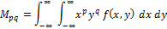
For p,q = 0, 1, 2, . . . Adapting this to scalar (greyscale) image with pixel intensities I(x,y), raw image M_{ij} are calculated by

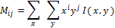

A uniqueness theorem (Hu [3]) states that if f(x,y) is piecewise continuous and has nonzero values only in a finite part of the xy plane, moments of all orders exist, and the moment sequence (M_{pq}) is uniquely determined by f(x,y). Conversely, (M_{pq}) uniquely determines f(x,y). In practice, the image is summarized with functions of a few lower order moments. Next, central moments are calculated using the following equations

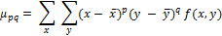

Where and are the components of the centroid. Using these central moments up to the desired order can be calculated. Moments η_{i j} where i + j ≥ 2 can be constructed to be invariant to both translation and changes in scale by dividing the corresponding central moment by the properly scaled (00)th moment, using the following formula

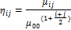

Hu set of moment invariants [3] for moments which are invariant under rotation, scaling and translation, are defined as

I1 = η₂₀ + η₀₂
I2 = (η₂₀ - η₀₂)² + 4
I3 = (η₃₀ - 3η₁₂)² + (3η₂₁ - η₀₃)²
I4 = (η₃₀ + η₁₂)² + (η₂₁ + η₀₃)²
I5 = (η₃₀ - 3η₁₂) (η₃₀ + η₁₂) [(η₃₀ + η₁₂)² –
3(η₂₁ - η₀₃)²] + (3η₂₁ - η₀₃)
(η₂₁ + η₀₃)[3(η₃₀ + η₁₂)² - (η₂₁ + η₀₃)²]

I6 = (η₂₀ - η₀₂) [(η₃₀ + η₁₂)² - (η₂₁ + η₀₃)²]
+ 4η₁₁(η₃₀ + η₁₂) (η₂₁ + η₀₃)
I7 = (3η₂₁ - η₀₃) (η₃₀ + η₁₂) [(η₃₀ + η₁₂)² –
3(η₂₁ + η₀₃)²] - (η₃₀ - 3η₁₂)
(η₂₁ + η₀₃)[3(η₃₀ + η₁₂)² - (η₂₁ + η₀₃)²]

- GLCM Texture Measurements
Gray-Level Co-occurrence matrix is created from the image by calculating how often a pixel with gray-level (grayscale intensity) value i occurs horizontally adjacent to a pixel with value j [5] [6]. The outcome of GLCM for each element (i , j) is computed by summing the pixel with the value i occurred in the particular spatial relationship to a pixel with value j in the input series [7] [8] [9]. The co-occurrence probability between gray levels i and j, C_{ij} is defined as

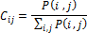

Where, P(i,j) represents number of occurrences of gray levels, i and j varies within the given image window for certain pairs of inter-pixel distance (δ) and orientation (θ). As explained by Haralick, after the computation of Gray-level Co-occurrence Matrix, the desired statistical texture measure can be found using co-occurrence probabilities. This probability measure can be defined as

The texture features can be calculated using the following equations

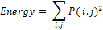

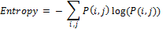

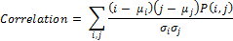

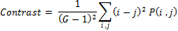

- multi-channel filtering and segmentation
A given image is first passed through a bank of Gabor filters. The impulse response of the Gabor filters is given in previous section. The Fourier representation of h(x,y) is given by:

where , and . The Fourier domain representation in above equation specifies the amount by which a filter modifies each frequency component of the input image. Texture segmentation requires simultaneous measurements in both spatial and spatial-frequency domains. Having pruned the multi-channel filtered images, we next subject filtered to a non-linear transformation. This transformation is given by,

Where α is a constant. This non-linear transformation changes the sinusoidal variations in the filtered image into square variations and so it can be viewed as a blob detector. We then define a texture energy measure over a small window around each transformed pixel in the select filtered images:

Where denotes the k^{th} filtered image, and is the corresponding texture energy. Using , we can associate with every pixel (x,y) in the original image a feature vector [] , where d is the number of selected filters or features. We input these feature vectors and their (x,y) positions into k-means clustering algorithm.
- Proposed Methodology
The CBIR system proposed in this work can be illustrated with the help of architectural design of the system, as shown in Fig. 1. It is divided into two modules on the basis of their functionalities. The two components are – retrieval and analysis, explained in the following sections.
- Retrieval
In this part CBIR technique is used. Initially the algorithm is run on the image database of MRI scans of brain, the shape and texture feature parameters are extracted and stored in a feature vector. The image transformed to hexagonal grid using the resampling process explained above is used for the feature extraction processes. When the query image is loaded, it undergoes the same process of resampling and then feature extraction, the results of which are stored in a separate feature vector (query feature vector). For retrieval process, extracted features of images in the database are compared with that of the features of the loaded query image. Comparison process involves calculation of Euclidean distances between the query feature vector and each record in the database feature vector. Least distance implies that the corresponding database image has high similarity with the query image. Based on these results, ten most similar images from the database are retrieved. The methods applied for shape and texture feature extraction has been covered in the below sub-sections.
- Shape Feature Extraction: Shape can be described by simple geometric features such as moment of inertia, skew invariants, centre of gravity etc. The extraction of shape features starts with detection of edges. For this purpose Gabor filter is applied on six scale values – 0, 2, 4, 8, 16, 32 and three orientations – 0⁰, 60⁰, 120⁰, resulting in 6x3 = 18 edge-maps. Out of these only those satisfying the threshold value are superimposed to get the final edge-map. The next step is to get the shape features by applying moment invariants. The moment invariants are applied to the second-level wavelet decomposition results of the final edge-map. Since, second-level wavelet decomposition gives four coefficient matrices, namely approximation,

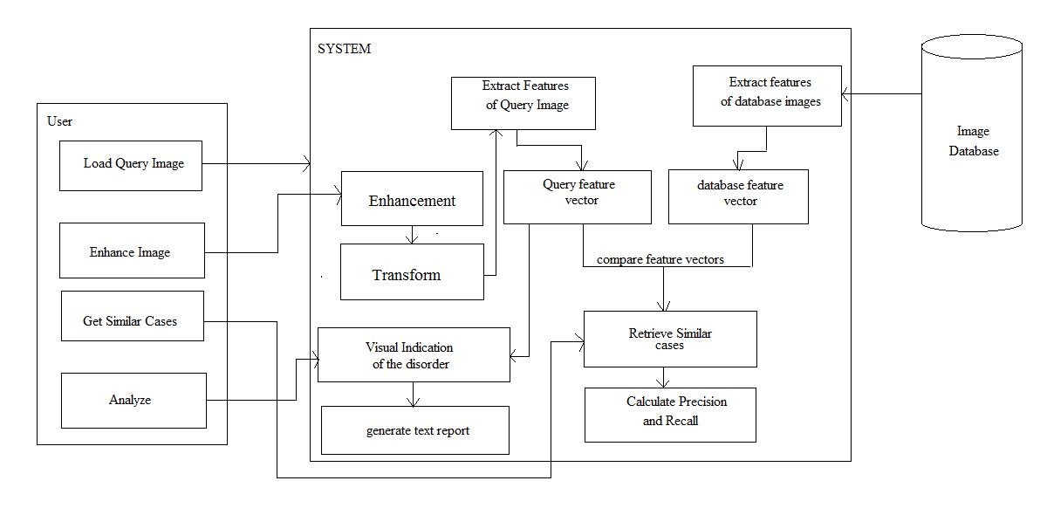

Fig. 1. Architectural design of the system

horizontal, vertical and diagonal, results in total of 28 values (7 for each of the 4 components). These values are stored as shape features in the feature vector table.
- Texture Feature Extraction: Important data regarding the structural arrangement of the surface is contained inside the texture features. Relationship between the surface and external environment can also be provided by them. For extraction of texture features, GLCM is used, which has been explained previously. In this study, first the co-occurrence matrix is created from which 13 texture parameters are calculated using the equations mentioned in previous section. The statistical texture measures used for this process include energy, entropy, correlation, contrast, sum of variances, inverse difference moment, information measure of correlation1, information measure of correlation2, sum average, sum entropy, sum variance, difference variance and difference entropy. These texture parameters are appended to the feature vector containing shape parameters. The combined feature vector is given in Table I.

TABLE I
FEATURE VECTOR TABLE
Image Id | Shape features  (7X4 = 28 values) | Texture features  (13 values)

The feature vector consists of 41 feature values (shape + texture) along with their corresponding image id.

- Distance Calculation: The database feature vector for all the images in the database is created in accordance with the above mentioned process of feature extraction so is the feature vector for the query image. The Euclidean distance between the query and each of the database feature vectors is computed using the following equation.

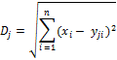

Where D_{j} = Euclidean distance for j^{th} image in the database, x_{i} = i^{th} feature value of the query image, y_{ji} = i^{th} feature value of the for j^{th} image in the database. Since there are 41 feature vector values n = 41. These distances are sorted in ascending order to retrieve the top 10 similar images.

- Identification of Ailment
The identification process starts with applying Gabor filter in frequency domain using the equation specified in the previous section. The 28 responses which are generated as an outcome of seven frequency values and four orientations for each frequency. As texture parameters, energy value for each pixel is calculated. To minimize computation, a window of size 5X5 is considered, making the value of M in the equation to be 5 and the window is shifted so as to cover the entire image under consideration. The constant α used in the equation for calculation of texture energy is taken to be 0.25. Based on the computed energy values, five clusters are obtained using the k-means clustering algorithm. Different colour is associated with each cluster, thus completing the segmentation of the image. The energy of the segmented image is compared with the energy values of the object (tumour, bleed or infarct). A visual indication is given of the affected region in the image if present.

- Results And Discussions
In this section the results obtained are shown and the performance evaluation in terms retrieval efficiency is discussed.
- Experimental Setup and Results
The system is tested over 1500 MRI scans of brain images collected from local scan centres form the image database. MATLAB is used as the development platform.

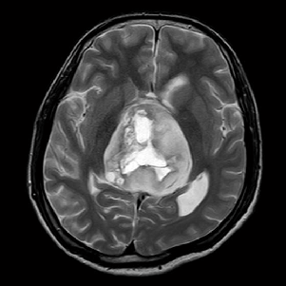
(a)
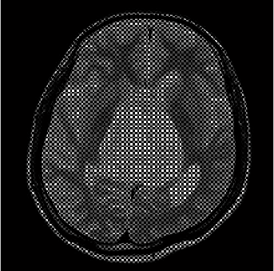
(b)
Fig. 2. (a) Query image; (b) Resampled image.

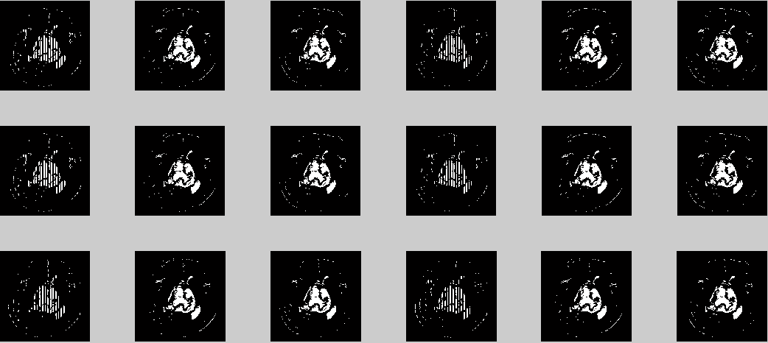
Fig. 3. Gabor responses.

The result of transforming a sample query image into hexagonal grid is shown in Fig. 2. Edge detection technique is applied on this resampled image. As previously mentioned Gabor filter will output 18 edge-maps. All these edge-maps are given in Fig. 3. Out of these responses those satisfying the threshold value are superimposed to obtain the final edge map, given in Fig. 4.
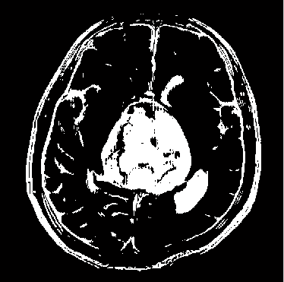
Fig. 4. Final edge-map

This edge map is subjected to second level decomposition and moment invariants are applied on them to extract the shape features, and store those features in a feature vector. For texture extraction, GLCM is created and statistical measures are calculated. These statistical measures are stored as texture features in the feature vector. The texture values are appended to the previously stored shape feature values in the same vector.
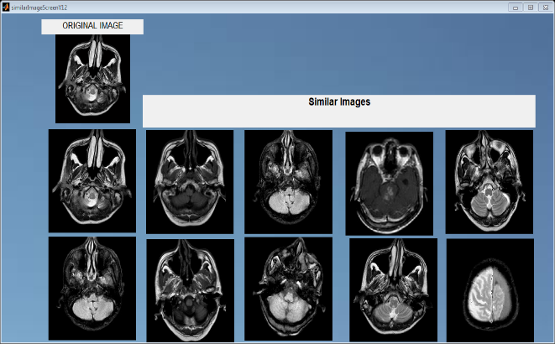
(a)
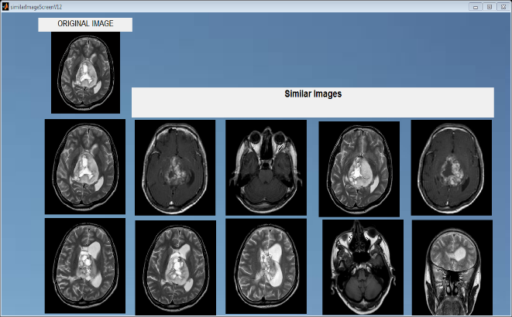
(b)
Fig. 5 (a) and (b). Retrieval output for two sample query images.

Retrieval results for two query images are shown in Fig. 5(a) and 5(b). The ten most similar images found after applying the methods discussed are displayed as the results.
The second module of the system under study, consists of image analysis. Based on texture parameters the defects are detected and visual indication of the affected region is provided. Fig.6. shows the segmented image obtained based on the texture energy values. One analysis result for each of the three pathologies under consideration is shown in Fig. 7.

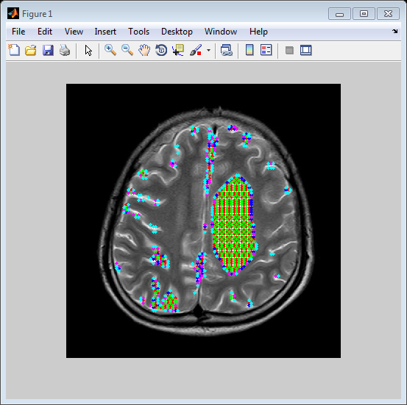
Fig. 6. Segmented image

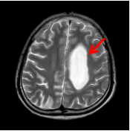
(a)
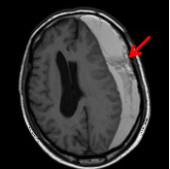
(b)
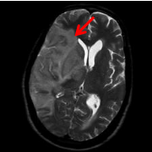
(c)
Fig. 7. Visual Indication of the affected regions for the defects: (a) Tumor, (b) Bleed and (c) Infarct

- Retrieval Efficiency
For showing the efficiency of retrieval, precision and recall values were calculated for four randomly selected images from the 1500 images of brain MRI scan from MATLAB workspace database. Formulas used for the calculation of precision and recall values are:

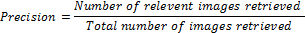

TABLE II shows the precision and recall values for the four query images randomly chosen. Precision varies from 70.0% to 90.0% and recall varies from 13.5% to 51.3%.

TABLE II
Precision and Recall values in %
Image Id | Precision | Recall
14 | 80.0 | 47.4
24 | 70.0 | 13.5
37 | 90.0 | 24.8
92 | 80.0 | 51.3

According to the table values, graphical representation of recall versus precision is shown in Fig. 7. The recall values on horizontal axis are of image Id 14, 24, 37 and 92, respectively.

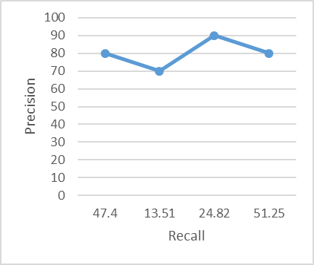
Fig. 7. Recall versus Precision graph

- Discussions
Hexagonal resampling increases the peak signal to noise ratio, thereby, facilitating better extraction of shape and texture features. Euclidean distance used for distance calculation results in improved retrieval efficiency. For, measuring the performance of the proposed system, traditional parameters such as precision and recall measurements are used and the results are presented in TABLE II and corresponding graphical representation is also presented in Fig. 7. For precision the system gives, minimum 70.0% to a maximum 90.0% of the result and to recall it gives minimum13.5% to a maximum 51.3% of the result. It shows that the precision gives better performance in relevant image retrieval out of the retrieved images and recall gives its own performance in relevant image retrieval out of total images available in the database.
The system is able to locate the affected region for the three pathologies, discussed previously. The sample results with the visual indication, pointing at the affected area, are presented in Fig. 6. Also the system provides a very good user interface for retrieving the images and their analysis.
- Conclusions
This study proposed a model for Content Based Image Retrieval by using shape and texture features of the images. Shape features are extracted from the hexagonal resampled image, which gives improved edge detection, by applying moment invariants on them. Using GLCM various statistical measures, representing the texture features, are computed. Final feature vector table contains both shape and texture features, resulting in improved retrieval. The measure of similarity between the query image and the database images is done by calculating the Euclidean distance. Smaller the distance, higher is the similarity.
The second component of the system consists of detection of ailment in the MRI scans of human brain for three pathologies – tumor, bleed and infarct. Texture features, calculated above, are used for the identification of abnormalities taken in consideration for this work. Visual indication is provided for the affected region in the brain for assistance to the doctors or other medical professionals in the process of analysis. The system has been developed successfully in an efficient manner to achieve the expected output. The system is designed with flexible and consistent flow for easy understanding.

- references

- http://en.wikipedia.org/wiki/Gabor_filter
- “Using Moment Invariants For Classifying Shapes On Large Scale Maps” Laura Keyes, Adam Winstanley; Department of Computer Science, National University of Ireland Maynooth, Co. Kildare, Ireland.
- “Visual Pattern Recognition by Moment Invariants”, M. K. Hu, IRE Trans. Info. Theory, vol. IT-8, pp.179-187, 1962
- “Hexagonal wavelet processing of digital, mammography”, A. Laine, S. Schuler, Medical Imaging 1993, Part of SPIE’s Thematic Applied Science and Engineering series, Newport Beach, California, February 14-19,1993.
- "Textural Features for Image Classification", Haralick, R.M., K. Shanmugan, and I. Dinstein, IEEE Transactions on Systems, Man, and Cybernetics, Vol. SMC-3, 1973, pp. 610-621.
- “Computer and Robot Vision: Vol. 1”, Haralick, R.M., and L.G. Shapiro., Addison-Wesley, 1992, p. 459
- “Content Based Medical Image Retrieval with Texture Content Using Gray Level Co-occurrence Matrix and K-Means Clustering Algorithms”, Ramamurthy, B. and K.R. Chandran; 1Department of CS, Sri Ramakrishna Engineering College, Coimbatore, India Department of CIS, PSG College of Technology, Coimbatore, India
- “Detection of abnormal texture in chest x-rays with reduction of ribs”, Park, M., J.S. Jin and L.S. Wilson, 2004. Proceedings of the Pan-Sydney Area Workshop on Visual Information Processing, (VIP’05), ACM, Australian Computer Society, Inc. Darlinghurst, Australia, pp: 71-74.
- “Rock texture retrieval using gray level co-occurrence matrix. Tampere University of Technology”, Partio, M., B. Cramariuc, M. Gabbouj and A. Visa, 2002.
- “Image information retrieval from incomplete queries using color and shape features”, Keshri Verma, Bikesh Kumar Singh, A. S. Thoke and Ankita Chan-drakar. Vol. 2(No. 4), December 2011.
- “Matlab as a tool in nuclear medicine image processing” Agapi Ploussi, Maria Lyra and Antonios Georgantzoglou, Radiation Physics Unit, A’ Radiology Department University of Athens, Greece, 2011.
- “Hexagonal parallel pattern transformation”, M.Golay, Vol. 18(No. 8):733-740, 1969.
- “Content based medical image retrieval with texture content using gray level co-occurrence matrix and k-means clustering algorithms”, B. Ramamurthy, Coimbatore India Department of CIS PSG College of Technology Coimbatore and K.R. Chandran Department of CS, Sri Ramakrishna Engineering College, 2012.
- “The process of hexagonally sampled two dimensional signals”, R.M.Mersereau, Vol. 67:930-949, 1979.
- “Image enhancement of medical images using gabor filter bank on hexagonal sampled grids”, K.A.Narayanankutty and Veni.S. 2003.
- “Gabor wavelets for image processing”, Jian Zhang, Yu Hu, Xin-Yi Wang, Wei Jiang, Ting-Zhi Shen, Department of Electronic Engineering School of Information Science and Technology, Beijing Institute of Technology, Beijing 100081 China. 2012.

